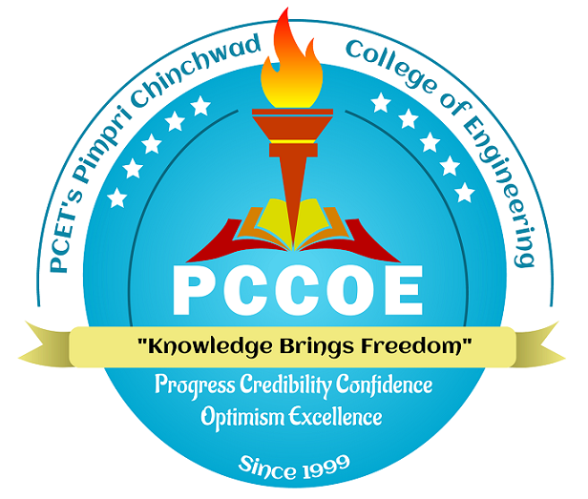 | Pimpri Chinchwad Education Trust’s  Pimpri Chinchwad College of Engineering  An Autonomous Institute  (Permanently affiliated to Savitribai Phule Pune University) | SET - {{Set}}
 |  | SEMESTER - {{Semester}}
Summative Assessment
{{Year}} B. Tech. ({{Branch}})
{{Course Name}}
[{{Course Code}}]
(Regulation:2020)
{{Semester}} Semester ({{Academic Year}})
Total No. of Questions-4 Total No. of Printed Pages-2
[Time:{{Total Time}}] [Max. Marks: {{Total Marks}}]
PRN

Instructions:
{{General Instructions}}
{{Question Here}}
Q.No. | Question | Difficulty  Level | Blooms Level | CO | Marks

